BACK TO THE TRACK 2020
Women at War
Until the early months of 1942, Australian women, except for nurses, had hardly been recognised by government as contributing to the war effort.
The events of 1941, and after, shook government to its core. If munitions targets were not met, if the armed services were to succeed, women would have to leave behind social norms and traditional spheres of employment, and be moved into spheres of male activity, from directing anti-aircraft guns and searchlights, driving trucks, delivering aircraft from factories to airfields to toiling as rural laborers, the government had turned from indifference, to a complete embracing of a total war effort. Australia would never be the same again.
Women now became very prominent in the military services within Australia
The threat of imminent attack by Japanese forces, by 1942, caused a further rethink of the role of women in the war. Now they were seen to be an important element of the actual armed forces.
Women’s Auxiliaries of the armed forces were now agreed to by the War Cabinet.
Branches of the services included,
Australian Army Nursing Service (AANS), mobilised on 4 September 1939, within a day of the declaration of hostilities
Australian Air Force Nursing Service (RAAFNS)
Voluntary Aid Detachments (VADs)
Australian Army Medical Women’s Service (AAMWS)
Women’s Royal Australian Navy (WRAN)
Women’s Auxiliary Australian Air Force (WAAAF)
Australian Women’s Army Service (AWAS)
Some members of the AWAS were trained to operate searchlight batteries. The 58th Anti Aircraft Searchlight Battery began on 17 July 1942 at Victoria Park, Adelaide. The first intake of 30 women was eventually swelled to 150.
The early days of training were full of incidents, as Nancy Alldritt recalled:
“Guard was mounted each night and until we were issued with .22 bore rifles a whistle was carried. One night a guard decided to try out the effect of blowing the whistle loudly and long. Nothing happened. Some girl were not happy at patrolling the camp in the middle of the night so arranged that a friend would join them for the two-hour watch. Marching, drilling, and later rifle drill began each morning after the ‘fatigues’. Unarmed combat, route marches and a number of lectures on everything connected with searchlights and their operation filled every hour of every day. Unarmed combat was taught..by a burly sergeant with a broken nose and cauliflower ear, which was not obtained from ballroom dancing.
He demonstrated the techniques by hurling girls in all directions and never letting the pupils hurl him…The first the light was operated in the parklands was an occasion not to be forgotten. When all the drill was completed, and the order given to expose, the light flashed out, straight into the eyes of a bus driver coming along Dequetteville Terrace. The light had not been elevated above 30 degrees. ‘Douse’, was quickly in coming but nothing was heard from the bus driver or his passengers who must have had a few nasty moments with 210 million candlepower lighting up their way
Back to the Track 2020 has invited members of the 58th A A Searchlight Battalion, to join the convoy re-enactment and 75th Commemorations for the end of World War II / VJ Day in Darwin.
Assistance will be requested from the NT Government and Veterans Affairs to help provide the support needed to enable the ladies to attend in 2020, health permitting.
Members include:
Name: Maiden Name Service Number Rank
Joan White Richer SF 64864 Lance Bombardier
Dolcie Vera Freeman Woon SF 64890 Gunner
Norma Rae Cotton McGregor SF 84360 Corporal
Dawn Aileen Hurst Denton SF 113101 Gunner
Elaine Elise Heath Phillips SF 84306 Private
Dianna Mary Watson Beresford SF 68191 Private
and member
Joan Haigs SF 84772 (Veteran – not searchlight)

The veterans will be joined by a searchlight re-enactment crew operating a fully restored Speary WWII searchlight, that will light up the night sky each night along the convoys travels and culminate in a spectacular light display in Darwin on the eve of the 75th Commemorations for the end of World War II / VJ Day to be held on Saturday 15th August 2020 at the Darwin Cenotaph.

It is hoped that the ladies may be able to join us in Alice Springs and in Darwin for commemorations (funding permitting) so the public can engage the convoy participants and thank the ladies for their service and revive the art of WWII searchlight operations in war time conditions.

Just try and stop them from getting involved again after 75 years.

We have been given permission by the ladies to carry and display for public display along the Track, their memories truck, and which contains their precious war time memories, uniforms, training manuals, ancillary equipment, tools and photographs from their days of war time service.

Further enquiries can be made by contacting:
Douglas Draeger Rita Thomas
BTTT 2020 Host / Convener Secretary – 58th AA Searchlight Battalion
PO Box 8607 PO Box 50
Alice Springs, NT, 0870 Stockport, SA, 5410
0428 676 741 0413 002 939
dougdraeger@hotmail.com ritawonderingfree@gmail.com
www.backtothetrack2020.com

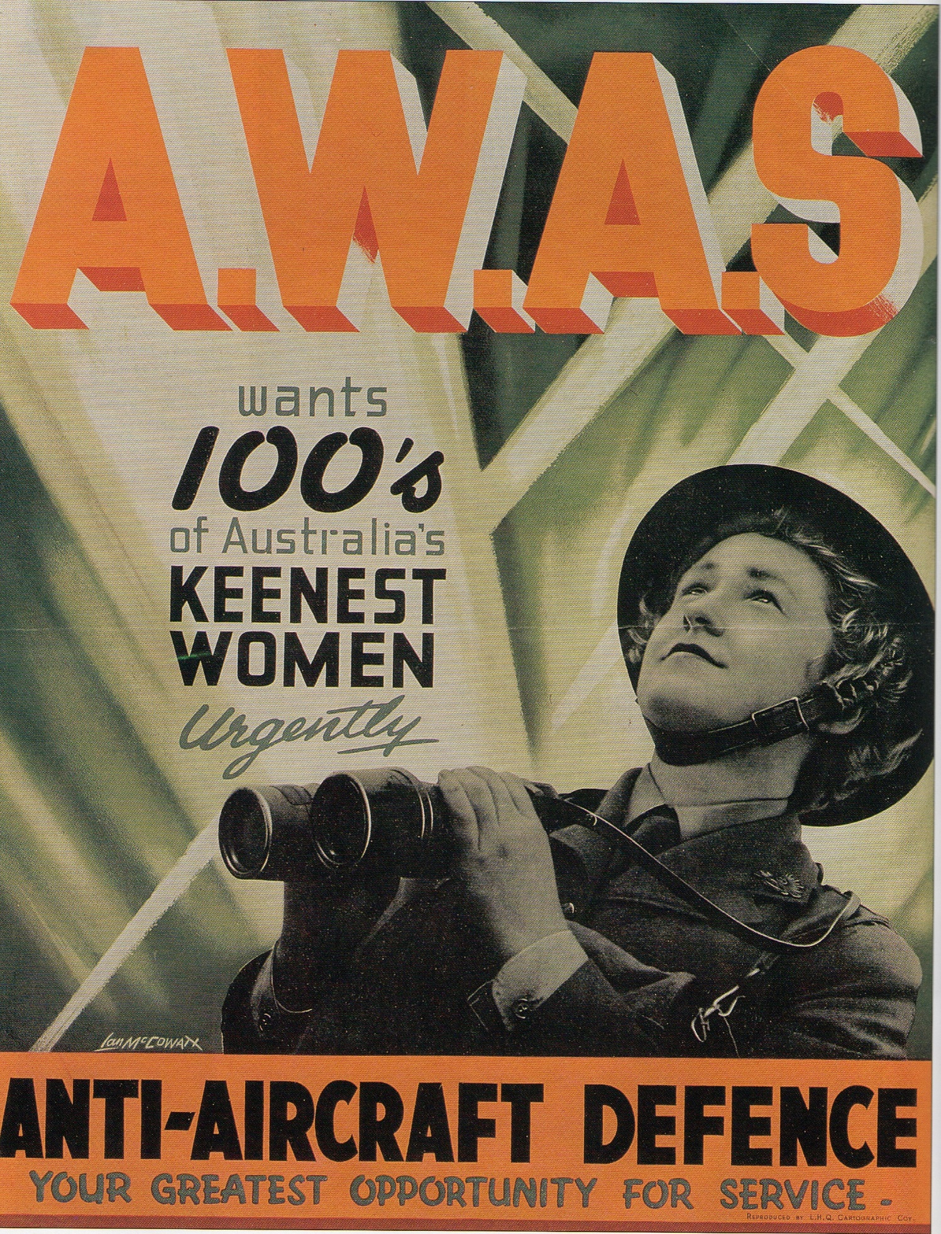

This poem was written by 58th AA Searchlight Battalion member, May Johnstone, after the war and recited at reunions
PEACE 1945

I am sitting in my tent where I have lived three years or more
Sitting on my palliasse that is hard and filled with straw
Trying to digest the news that peace at last has come
Trying to believe it’s true that we the war have won.

No more marching, no more drill, no more eating army stew,
No more frantic evening darning when a kit inspection’s due.
No more trying to look glamorous when going to a dance
In the everlasting khaki that did nothing for romance.
No more death and no more sorrow, no more parting, no more tears,
I could see the grand reunions and the many happy years.

Then I thought about the girls with whom I’d spent so many days,
And I knew that I would miss them with parting of the ways,
I knew that we had formed a bond that would never ever wane,
And if I could turn the pages back, I’d do it all a.gain

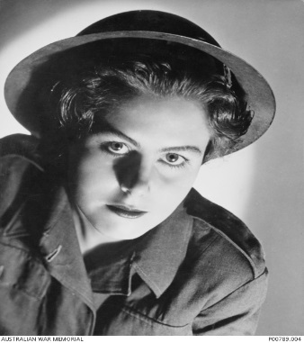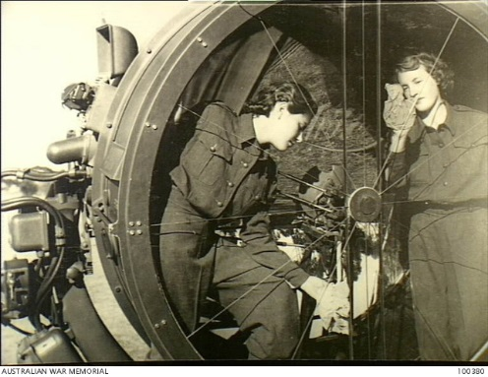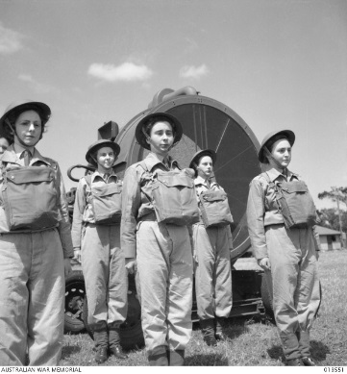
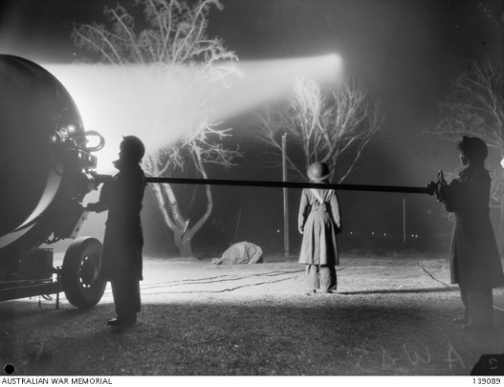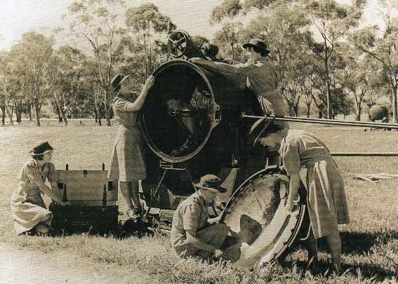

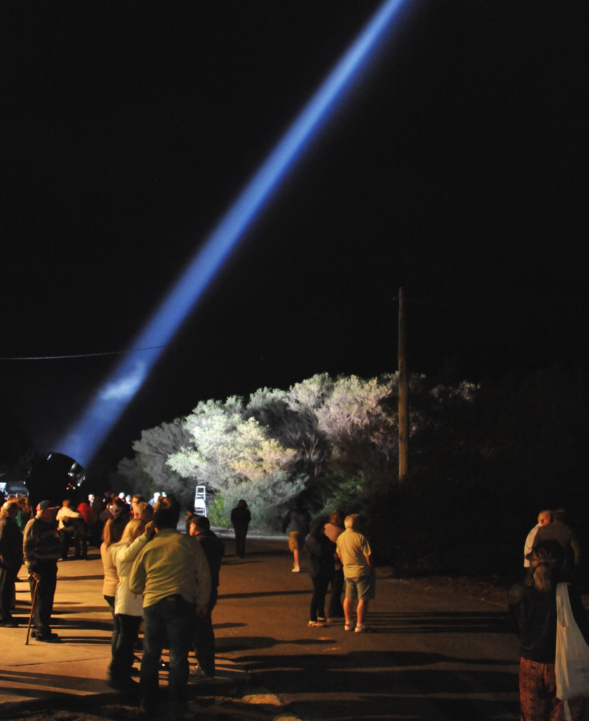
Restored, fully operational, 1942 60 inch Speary Searchlight and AC Generator in action
(Corowa NSW 2018)
More information
https://www.awm.gov.au/collection/C373135

