Indigenous Australians at war
WARNING: Aboriginal and Torres Strait Islanders are warned that the following page may contain images of deceased persons.

A brief history of Indigenous Australians at War
by John Moremon
Indigenous Australians have served in virtually every conflict and peace keeping mission in which Australia has participated since the start of last century – from the Boer War to East Timor, and most likely Afghanistan also.
Aboriginal and Torres Strait Islander societies had traditions of warfare that many Australians may not realise. In traditional societies, inter-group conflicts occurred at intervals, although not on the scale of full-blown wars on other continents. After 1788, groups in several areas actively resisted European settlement. Conflict usually was slow to start but could escalate suddenly, with hit-and-run raids or even pitched battles being fought. In some areas, this ‘frontier warfare’ lasted for 20 or 30 years. Invariably, Europeans mounted punitive expeditions to ‘teach the blacks a lesson’ and gradually suppressed resistance with organised campaigns and modern weaponry. Indigenous groups, whose men were armed mostly with spears, suffered heavy losses and in some areas were virtually wiped out. By about 1880, frontier warfare had ended in most of Australia but sporadic fighting and reprisals continued in north Queensland until 1900, in the Kimberley region of Western Australia until the 1920s and in central Australia into the 1930s.
By the mid-19th century, colonial military and police units commonly employed Aborigines as guides and ‘black trackers’. When Australians gathered to celebrate Federation on 1 January 1901, several Aborigines were participating in the Boer War, serving in South Africa as trackers attached to mounted infantry units. They searched for, and fought, Boer commandoes.
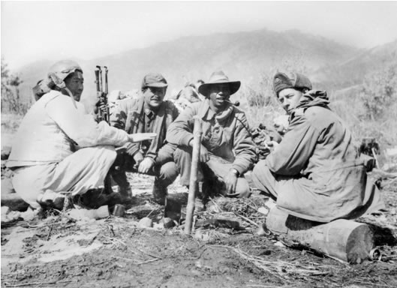
Three members of the 3rd Battalion, The Royal Australian Regiment (3RAR), confer with a North Korean interpreter (left) who is serving with the battalion. The Australian soldiers are (left to right): Warrant Officer (WO) W.J. ('Bill') Harrison, the Regimental Sergeant Major (RSM); 3/37678 Lieutenant (Lt) Reginald Walter Saunders, second-in-command of 'A' Company; 3/46514 Private (Pte) W.H. ('Alby') Alberts of the Sniper Section. The men are gathered around a small campfire on which a billy is boiling. All three Australian soldiers are wearing padded windproof jackets as protection against the cold, while WO Harrison and Pte Alberts are also wearing pile caps. Lt Saunders is smoking a pipe and Pte Alberts a cigarette. The Korean interpreter, who is wearing a traditional fur-lined cap and other warm clothing, is holding a Bren gun. Lt Saunders later became the first Aboriginal serviceman to command a rifle company
In the first half of the 20th century non-Europeans officially were barred from serving in Australia’s armed forces but during World War I approximately 500 Aborigines and a few Torres Strait Islanders managed to enlist. Sometimes, their skin was deemed ‘white enough’. At other times (particularly after heavy losses were suffered on the Western Front) recruiting officers didn’t care so much about the colour of a man’s skin so long as he was willing to sign on the dotted line – thus putting his life on the line for King and Country. The precise number of Indigenous Australians who volunteered is not known because, ironically, ethnicity was not actually recorded on personnel files. In the Army, a man became a soldier irrespective of the colour of his skin.
Some might find it strange that Aborigines and Torres Strait Islanders wanted to serve a country that did not recognise them as citizens (until 1967). Reasons for enlistment were many: some hoped that war service might help the Indigenous campaign for citizenship and equality; some believed the war was just; others sought adventure, good pay, or joined up because mates did.
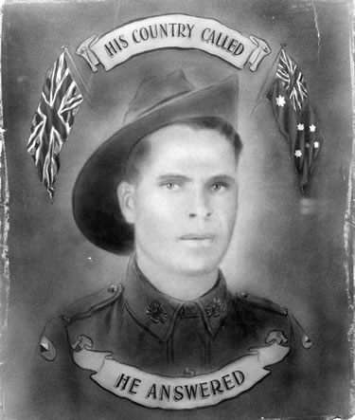
Illuminated portrait of Aboriginal serviceman, Private Frederick Beale.
Indigenous Australians were present in almost every Australian campaign of World War I. In the heat of battle, survival could come down to relying on your mates so racism, for once, took a back seat. White and black soldiers forged friendships in the trenches of Gallipoli and the Western Front or on horseback with the Light Horse in the Middle East. In common with other soldiers, Indigenous servicemen generally were anonymous men who earned neither bravery awards nor mentions in the official history. However, some were decorated for outstanding actions. Corporal Albert Knight, 43rd Battalion, and Private William Irwin, 33rd Battalion, were each awarded the Distinguished Conduct Medal – second only to the Victoria Cross for men in their ranks – and others the Military Medal. Private William Rawlings, 29th Battalion, was awarded his Military Medal for ‘rare bravery in the performance of his duty’ in July 1917. He was killed in action the following year.
Probably about a third of the Indigenous soldiers who served overseas were killed in action or died of wounds or disease. Some were sent home with horrible wounds. At least three were captured. Private Douglas Grant, 13th Battalion, suffered the indignity of being separated from his fellow Australian prisoners of war to be studied by German doctors and anthropologists. He was then placed in charge of a camp of black prisoners (probably French colonial or Indian troops) reinforcing the fact that, although a combat soldier, Grant’s captors saw him as ‘different’.
After the war, Indigenous veterans found that their war service counted for little. Douglas Grant, for example, involved himself in ex-service affairs but was continually frustrated by racism and lack of recognition. Very few Indigenous veterans were granted a soldier settler block. They were not given full citizenship and rights and still had to live under the so-called ‘Protection Acts’ that imposed strict control over almost every aspect of Aboriginal and Torres Strait Islander life.
Despite the disappointment of Indigenous veterans after World War I, Aborigines and Torres Strait Islanders made a greater contribution to Australia’s defence in World War II. Some Indigenous Australians argued against war service but hundreds joined up anyway. They found it surprisingly easy to enlist in the first year of the war but from late 1940 Indigenous men and some women were turned away on grounds of race after the Government toughened the rules of enlistment to exclude many non-Europeans. However, even then, some managed to get around the colour bar.
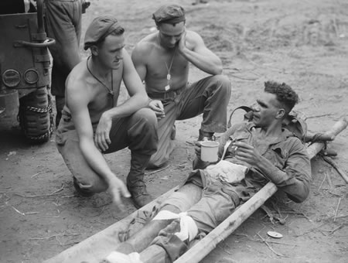
Corporal G.T. Mills and Private R.A. White chatting to Private L. Fuller while awaiting jeep ambulance transport.
Some travelled long distances to enlist. For instance, Torres Strait Islanders Charles Mene, Ted Loban and Victor Blanco joined the militia at the start of the war in September 1939 and then transferred to the 2nd Australian Imperial Force (AIF) for service overseas. They travelled to Brisbane and were posted to the 1st Anti-Tank Regiment. Gunner Loban was badly wounded in Greece in 1941 and discharged the following year. After transferring to the infantry, Mene (2/33rd Battalion) and Blanco (2/31st) served right through the war – including on the Kokoda Track.
Indigenous servicemen in regular the militia, AIF, Royal Australian Air Force (RAAF) and Royal Australian Navy (RAN) received equal pay (almost unheard-of in civilian jobs), could expect promotion on merit, and forged friendships with white men. On the other hand, even in uniform some were refused service in pubs or endured racial taunts from other soldiers – usually men they did not serve closely with. War service was thus a mixed experience.
Invariably, the decision to enlist cost more Indigenous men their lives. Edward Nannup, a West Australian, enlisted in July 1941 and was reported missing in action, presumed killed, with the 2/2nd Pioneer Battalion in Java in March 1942. Another West Australian, Herbert Mallard, was posted to the 2/11th Battalion and killed in action in New Guinea in May 1945; his brother, George, served in the 2/28th Battalion and survived the war. Thomas Gray, a stockman from Yalingup, Western Australia, was posted to the 2/16th Battalion but was killed in action in Syria in June 1941. Harry Saunders, a Victorian and son of an Aboriginal veteran, served in the 2/14th Battalion on the Kokoda Track but was killed at Gona, Papua, in November 1942.
Harry Saunders’ brother, Reginald, became probably the best-known Indigenous serviceman. Named after his uncle, William Reginald Rawlings MM (killed in action in 1918), Reg joined up in 1940. He served in the 2/7th Battalion in Libya, Greece, Crete – spending a year on the run after the Germans captured the island – and New Guinea. Having proved himself an exceptional junior leader, he was sent to an Officer Training Course and commissioned in November 1944 – the first Indigenous military officer. He enlisted again in 1950 to serve in the Korean War. Captain Saunders led a company of 3 Battalion, Royal Australian Regiment in the Battle of Kapyong.
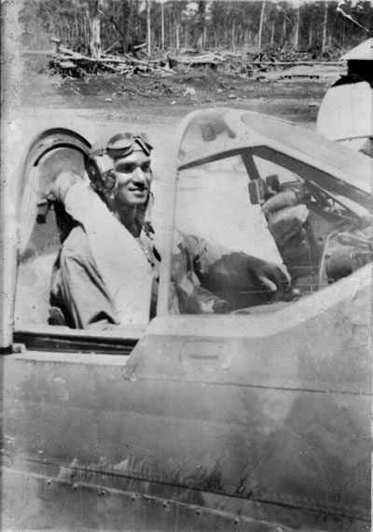
Sergeant Leonard Victor Waters sitting in the cockpit of P40N Kittyhawk.
Another remarkable man was Warrant Officer Leonard Waters, a Queenslander, who was the first Indigenous Australian to earn his ‘wings’ as a pilot. During 1944-45, Waters served in 78 Squadron RAAF, flying Kittyhawk fighters in Dutch New Guinea, Morotai and Borneo, bombing and strafing Japanese positions. Appropriately, his Kittyhawk was named ‘Black Magic’.
Other Indigenous men and women enlisted but, along with thousands of other personnel, stayed in Australia. Dick Ball, a Queenslander, joined the RAN and was aboard the boomship HMAS Karangi in Darwin Harbour when the Japanese bombed Darwin on 19 February 1942. Leslie Yuke, from the same area, served in the 2/5th Armoured Regiment and transport units; his brother, Stanley, was in the Signal Corps overseas. Alex Taylor enlisted in the RAAF in Adelaide and served at Darwin as a flight rigger in 7 Repair and Servicing Unit and 20 Squadron, servicing Catalina flying-boats.
In all, an estimated 3,000 Aborigines and Torres Strait Islanders served in the armed forces in World War II – many in specially raised Indigenous units. A Torres Strait Light Infantry Battalion was formed in 1941, primarily to protect Torres Strait. In late 1943 some of its men were sent to Dutch New Guinea; on 17 December 1943, a river patrol encountered two enemy barges and in the exchange of fire Lance-Corporal A. Barbouttis was killed and six others wounded.
The experience of troops in these Indigenous units differed markedly from those serving in non-Indigenous units. For instance, they were paid less than other troops (roughly half-pay) and, unless they served overseas, did not have access to many veterans’ benefits. It took four decades of passionate campaigning for anomalies to be rectified, for instance with the grant of back-pay.
Some Aborigines and Torres Strait Islanders in northern Australia joined irregular units that patrolled the extensive coastline and searched for crashed enemy and Allied airmen. Men in these units were not formally enlisted, and it took over four decades for their services to be recognised. At least 3,000 others worked for the military as labourers. A handful joined the United States Army, serving in water transport units.
Indigenous women also enlisted. Kathleen Ruska, of the Noonuccal people of Stradbroke Island, enlisted in the Australian Women’s Army Service – she later gained fame as the celebrated poet, Kath Walker, ultimately reverting to her Indigenous name, Oodgeroo Noonuccal. Her cousin, Winnie Iselin, joined the Australian Medical Women’s Army Service.
Both of Kathleen Ruska’s brothers enlisted, serving in the 2/26th Battalion, a Queensland unit that contained several Aborigines and Torres Strait Islanders. They fought in Malaya and Singapore but were captured when the British Empire garrison surrendered. The prisoners endured shocking slave labour conditions, and several Indigenous men were among the many Australians who died in captivity. Private John Knox, 2/26th Battalion, died of illness in Changi in August 1942. Private George Cubby, 2/26th Battalion, died on the infamous Burma-Thailand Railway, as did Private Cyril Brockman, a West Australian in the 2/3rd Machine Gun Battalion. Another Queenslander, Private Colin Ball, 8th Division Signals, died in Borneo on the Sandakan-Ranau death march in June 1945.
Flight Sergeant Arnold Lockyer, a West Australian, was among the last Australians to die in the war. A flight engineer and air gunner in 24 Squadron RAAF, flying Liberator bombers, he was shot down in July 1945 over the Celebes Islands (in Indonesia). Lockyer parachuted from the burning bomber and along with another crewman was captured by the Japanese. Tragically, both men were executed on 21 August 1945, six days after the war ended. Three other members of the Lockyer family served – two overseas in the 2/24th Battalion – with Private Eric Lockyer killed in action at Tarakan in May 1945.
A few Indigenous Australians were decorated for bravery. One was Private Timothy Hughes, a South Australian who served in the 2/10th Battalion. A ‘Rat of Tobruk’, he later won the Military Medal for coolness and bravery under fire while attacking Japanese positions at Buna, Papua, and went on to serve in the New Guinea and Borneo campaigns. A New South Welshman, Trooper Clive Upright, 2/7th Commando Squadron, was awarded the Military Medal for his actions in attacking the village of Sauri, New Guinea, in May 1945; Upright stood up in full view of the enemy to better direct machine-gun fire onto an enemy position.
Despite having been prepared to fight and die for their country, war service again failed to translate into full citizenship and recognition for Indigenous Australians. Indigenous veterans could still be denied a drink in pubs, which was potentially an issue if they attended unit reunions, and they felt marginalised by conservative ex-service organisations that frequently railed against Indigenous rights. On the other hand, they could march proudly with their mates on Anzac Day.
Indigenous Australians continued serving after World War II. Probably the best known of the post-World War II period was Charles Mene, one of the Torres Strait Islanders who enlisted in 1939. After the war, he went to Japan with the British Commonwealth Occupation Force (BCOF) and later served in the Korean War, being awarded the Military Medal for leadership and coolness in battle, and in Malaya.
Dozens of other Indigenous Australians served in the Malayan Emergency against Communist guerrillas, in Borneo against Indonesian forces, and the Vietnam War. Private Noel Brown, a Queenslander, was considered by his platoon commander in Malaya ‘an extremely good soldier in the bush, using all the natural skills he inherited’. Corporal Ron ‘Harry’ Harris, a West Australian, served in Malaysia before transferring to the elite Special Air Service (SAS) Regiment but was accidentally killed by ‘friendly fire’ in South Vietnam in January 1969. Corporal Norman Womal, a Queenslander, served in South Vietnam with 5 Battalion, Royal Australian Regiment, but on 17 October 1966 he was shot in the throat in an enemy ambush and, lying in an exposed position, held his throat and continued to direct the fire of machine-gunners. He died of his wounds and received a posthumous Mention in Despatches for his bravery.
Indigenous Australians continue to serve in the regular and reserve forces. In northern Australia, three Regional Force Surveillance Units complement other units based there. The 51st Far North Queensland Regiment, the Pilbara Regiment in Western Australia, and the North West Mobile Force (Norforce) in north-east Western Australia and the Northern Territory contain many reservists and some regular troops drawn from Indigenous communities as well as non-Indigenous troops. These units effectively are the ‘eyes and ears’ of the northern land forces.
Other Indigenous Australians serve in reserve units in other States or in the regular forces, serving anywhere in Australia or overseas where Australian forces are sent. Corporal Rick Morris, for example, served in East Timor with the 17th Construction Squadron, Royal Australian Engineers, carrying on a Indigenous family tradition stretching back to World War I – his grandfather, Frederick Lovett, serving in the 4th Light Horse Regiment, one of five brothers who enlisted in that war.
For many years, the service of Indigenous Australians was not adequately recognised but strong efforts have been made to change this at individual, armed forces and government levels. In recent years, Indigenous and non-Indigenous writers have published books and articles on Aboriginal servicemen and women, and websites have appeared. In contrast to the early part of last century, the Australian Defence Force actively recruits in Indigenous communities for reserve and regular forces. In 1994 an Aboriginal and Torres Strait Islander Memorial was erected in a bushland setting behind the Australian War Memorial in Canberra, while inside displays relating to Indigenous Australians have been upgraded and a very successful exhibition on Indigenous Australians at war, ‘Too Dark for the Light Horse’, was organised and has toured the country. The Department of Veterans’ Affairs has a campaign to identify Indigenous members of the veteran community, with up to 7,000 Indigenous veterans, war widows and dependants in the community.
Symbolically, the National Office of the Department of Veterans’ Affairs at Woden, ACT, occupies Lovett Tower, renamed in 2000 to honour the Lovett family (of the Gunditjmara people in Victoria) whose family members have served in virtually every war and major troop deployment since World War I.

